When To Plant Your Amaryllis Bulbs
Timing is everything so calculate when you want your amaryllis to bloom.
Once planted, amaryllis bulbs bloom in 8 to 10 weeks so time bulb planting according to when you want the flowers to be in full bloom. For flowers during the Christmas season, start bulbs just after Halloween. For Valentine’s blooms, plant around New Year’s Day.
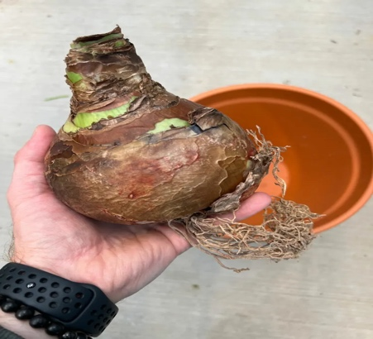

How To Plant an Amaryllis Bulb
- Amaryllis bulbs bloom best when they are crowded in their pots. So, choose a container with good drainage that fits the bulb snugly, allowing just an inch or 2 of space around the edges of the bulb. Use a heavier pot and avoid lightweight plastic pots. The reason being is your plant will become top heavy when it blooms.
- Fill the pot part way up with fresh potting soil high in organic matter and tamp the soil down. A good rule of thumb is to use 2 or 3 parts all-purpose potting soil, along with 1 part perlite or charcoal. Set the bulb into the soil, spreading the roots, then fill in around the bulb until the soil covers about 2/3 of the bulb. The top third of the bulb should be exposed.

- It is a good idea to place a bamboo stake alongside the bulb as you fill the container with soil to support the blooms once they emerge. Placing the stake now will help you avoid damaging the roots or bulb later.
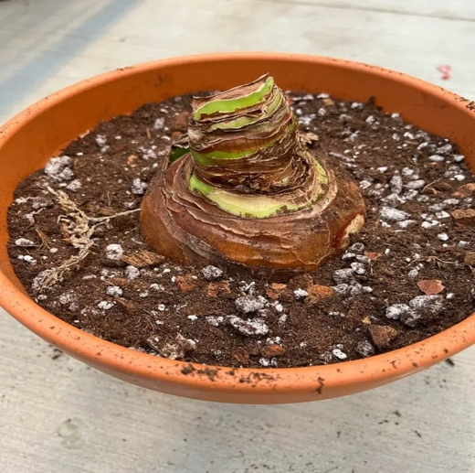

- After planting, water the bulb until the soil is damp, allowing excess water to drain from the container. Then place the pot on a drainage tray and set in a warm, sunny or somewhat sunny location.

- Turn the pot every few days once the stalk emerges to provide uniform light exposure on all sides. This encourages the stalk to grow straight. Once the flowers open, move the container away from direct light and other sources of heat. Amaryllis blooms will last longer if kept in a cooler location.

